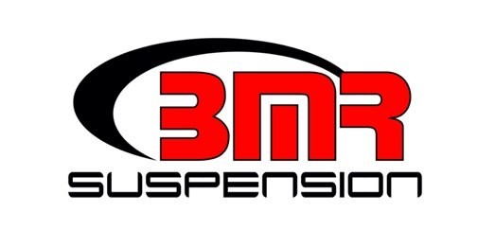

FOR IMMEDIATE RELEASE

BMR Suspension Front and Rear Sway Bar Kit for 1982-1992 F-Body

SB330 - $539.95

Improve handling, reduce body roll, and increase cornering stability with a non-adjustable sway bar kit for the Third Gen F-Body from BMR Suspension. Designed from 35mm (front) and 25mm (rear) DOM steel tubing, the BMR sway bars are cold formed to better resist torsional fatigue and retain "memory" far longer than conventional hot-formed bars. The BMR Sway Bar Kit (SB330) gives you 129% (front) and 149% (rear) increase in sway bar rate over the stock bars, reducing body roll and improving handling. BMR Suspension designed these sway bars for street performance, autocross, and road race applications. The SB330 sway bar kit is non-adjustable for a fixed design. They attach to the car with 88-durometer polyurethane bushings, greatly reducing the deflection seen in rubber bushings. Thrust washers locate the sway bars, eliminating lateral movement under aggressive cornering. Front sway bar (SB331) and rear sway bar (SB003) are also sold separately. Installation time is 2-3 hours. Available in black hammertone or red powdercoat. Proudly made in the U.S.A.!

To preview all of BMR’s high-performance suspension parts, please visit www.bmrsuspension.com, email sales@bmrsuspension.com, or contact them at BMR Suspension, 928 Sligh Ave, Seffner, FL 33584, 813-986-9302, Fax: 813-986-8055.

